Operations/Work/Job Activity covered by this assessment: Plasma (Sample)
Required Personal Protective Equipment (PPE) :

Safety glasses must be worn at times. |   Long and loose hair must be contained.
  Appropriate footwear with substantial uppers must be worn. |   Close fitting/protective clothing to cover arms and legs must be worn.
Respiratory protection devices required. |   Oil free leather gloves and spats must be worn.

Hearing protection must be used when using this machine.

Loading & Unloading Check:
- Ensure no slip/trip is present in work pass and walk ways.
- Ensure that work area is clean and clear of grease, oil and any flammable materials.
- Refer Work Instructions PSP/WI/14 while handling.
Operations Procedure:

Identify the powder to be plasma sprayed on the sample.

Refer Data evaluation card for the parameters to be set for plasma spraying.

Discuss any doubts on parameters with Supervisor.

Measure the thickness of one of the grit blasted samples selected for plasma spraying.

Fix the samples in the sample holder as shown in Fig 1.

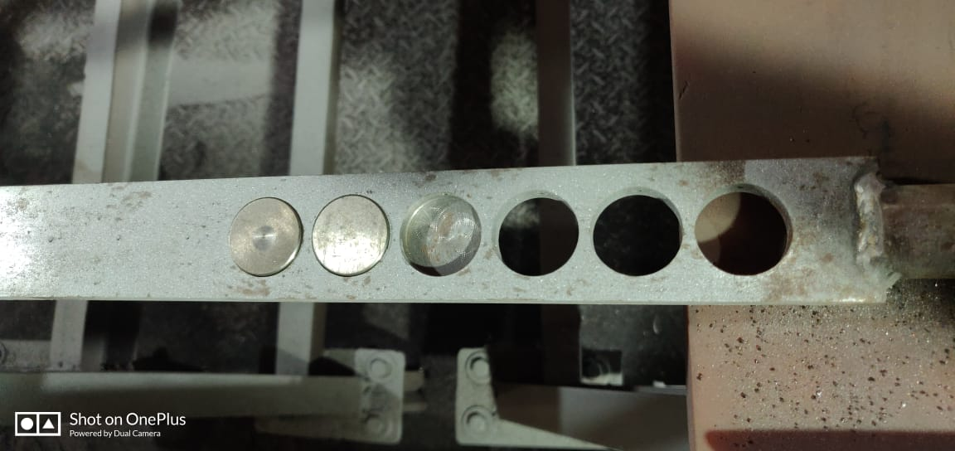
Fig 1

Load the sample on the chuck and hold it in position by clamp properly

Start Exhaust Fans, Chiller, Water Pump and Capacitor before starting the Plasma Control Unit.

Arrange new Argon, Hydrogen and Nitrogen cylinders near to the plasma control unit and connect it to the respective lines in the control unit as shown in Figure 2

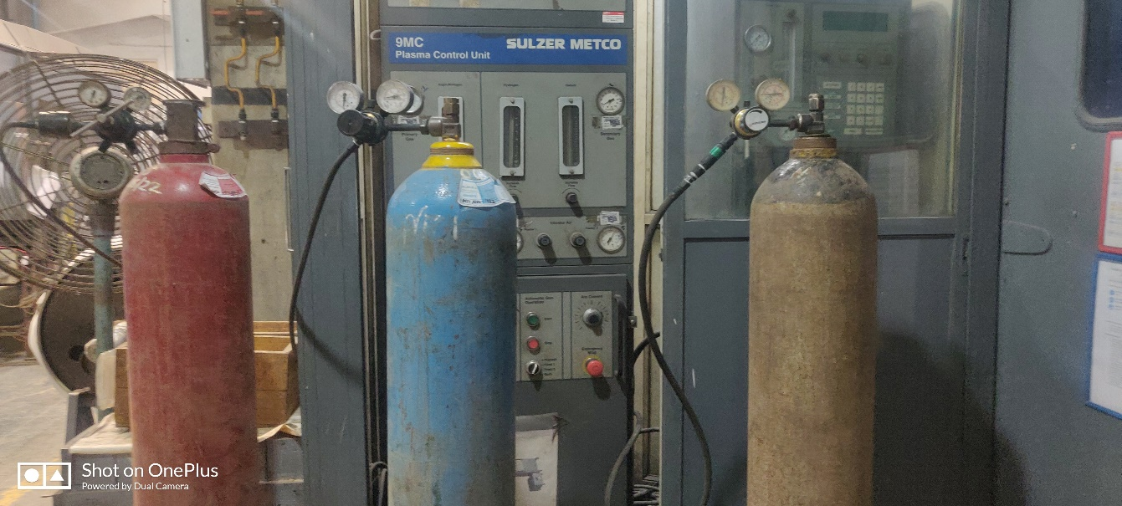
Ar
H2
N2

Fig 2

Connect another Nitrogen Cylinder to the Nozzle for use as nitrogen curtain under the sample and set the pressure

Weigh 1 kg of selected powder

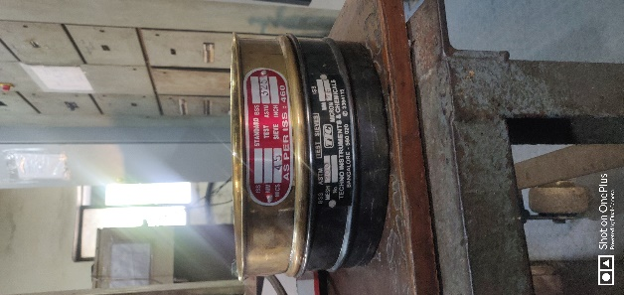
Take small quantity of selected powder viz., 200 gms and sieve the same using mesh 200 for 2-3 minutes by tapping on the top of the mesh on all sides and collect the powders in mesh 325 as shown in Fig 3

Fig 3


Sieve the powders retained in 325 mesh for 2-3 minutes so that fines are passed through this sieve Fig 4.

Fig 4

Store the sieved powder in a new clean container and repeat process 11 and 12 till 1 kg of powders is sieved and collected

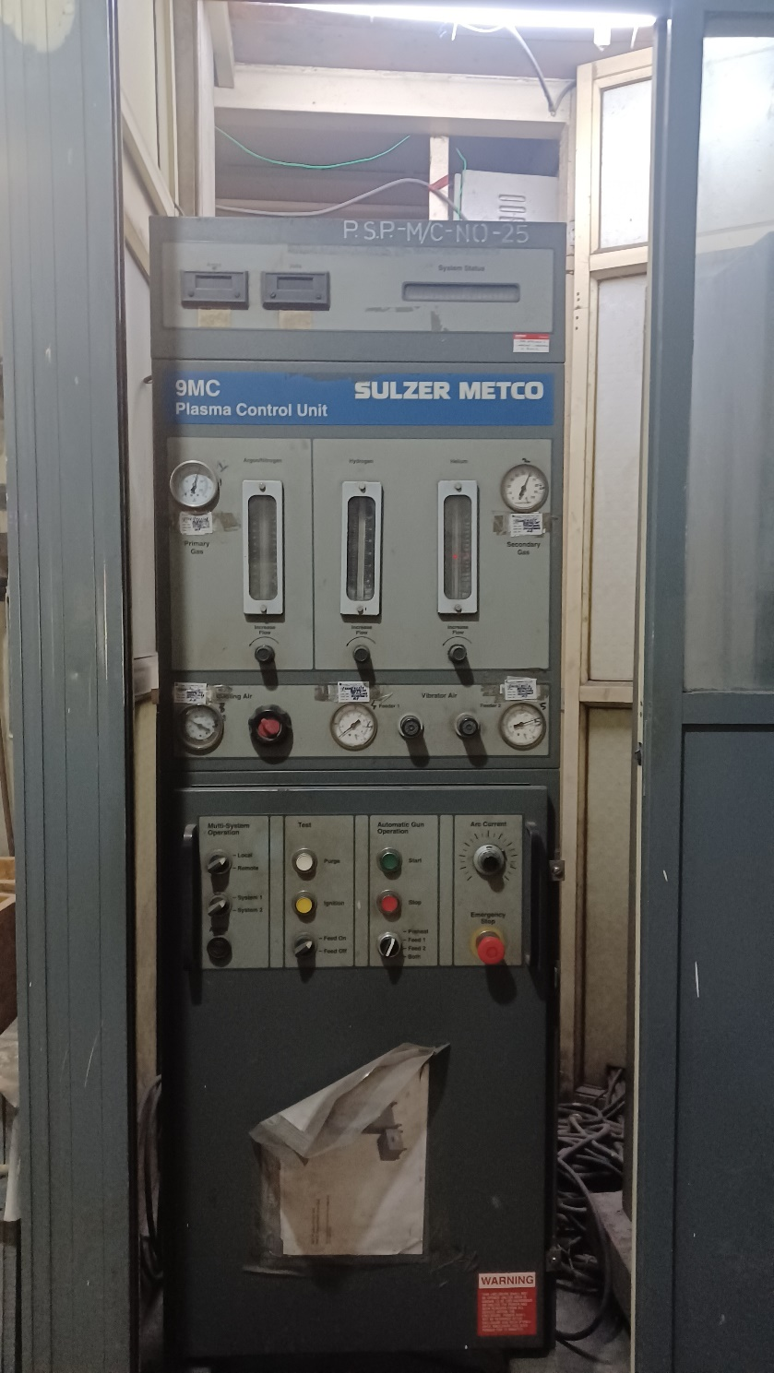
Check Argon & Hydrogen Flow & Pressure on the gauges and Flow meter Tubes. Fig 5

Check the Nitrogen gas flow (Air jet) for ensuring no moisture /water comes through it.

Check and Set DC Volts and DC Amperes Reading.

Fig 6

Ensure the set DC volts near the Gun and Amperage in the power cable through Multimeter
Fig 5

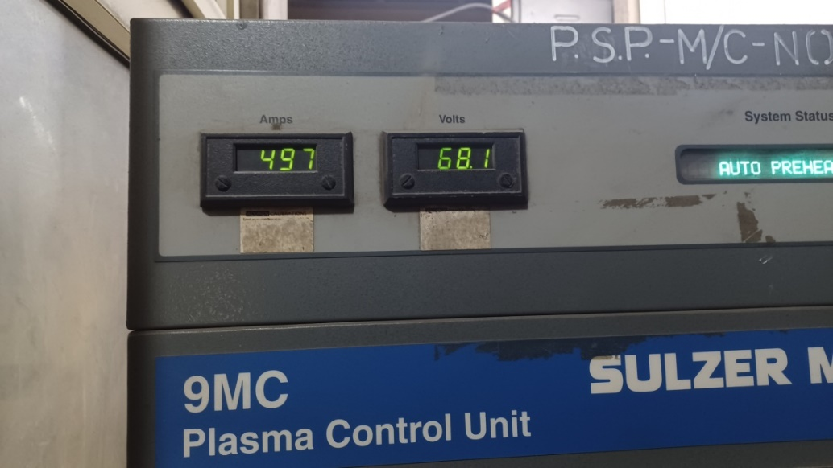
Pre-heat the sieved powder in the Oven and maintain the temperature to 120 C for one hour.

Clean the chamber in the Powder feed hopper with high pressure Air jet spray to remove any contaminants. Fig 7
Fig 6

Pour the sieved powder in the powder feed hopper

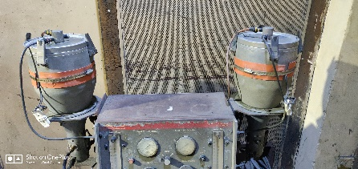
Fig 7

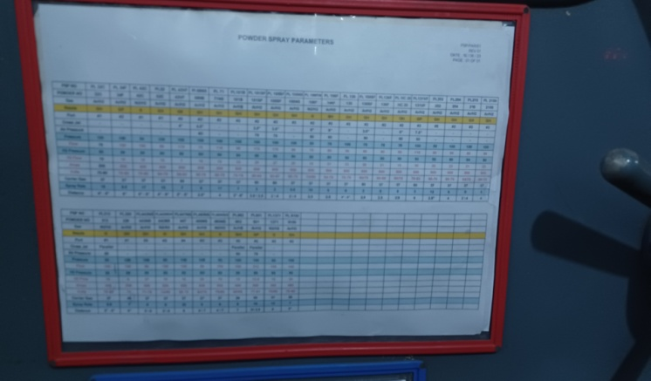

Measure the powder flow rate as per parameter, and then set the flow meter reading. [Refer Parameter Chart no.–PSP/Parameter/Rev1] Fig 8

Fig 8

Refer Job Card or Data Evaluation Card and instructions given by Supervisor.

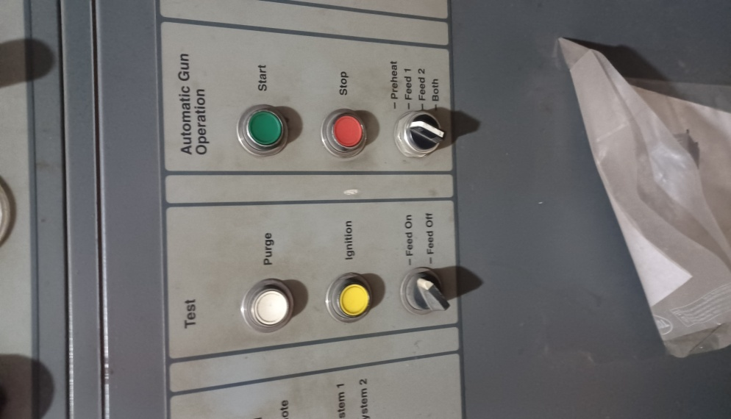
Close the Acoustic Door and purge the gases from the Plasma control unit [A], press the ignition switch [B] to check the Arc in the plasma gun. Fig.9

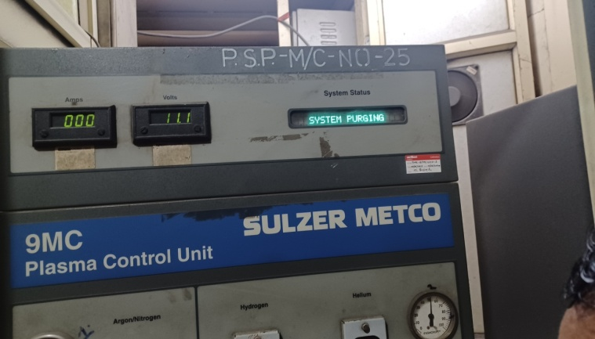
Fig 9

Press the Start switch for ignition. Wait for the gun to ramp up till you get the desired Amp and volts are displayed on the Plasma Control unit as per the parameter selected.
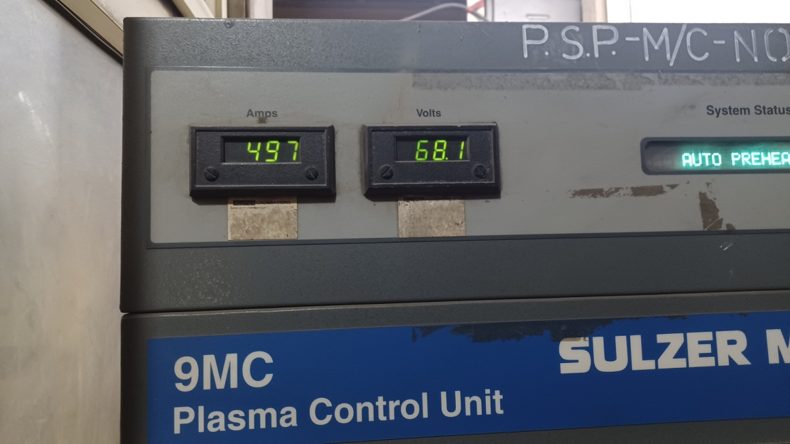

Pre-heat the skin temperature of the job up to 100ºC check with pyrometer. (Do not pre-heat the Aluminium components).

Switch ON the nitrogen curtain flow under the samples to the desired pressure.

Switch “ON” Powder feeder and wait till the powder flow is stabilized and spray the job layer by layer to get a uniform thickness all over the sample.

Make sure that while spraying the job temperature does not exceed 100⁰C. You can use Nitrogen for cooling the job while spraying.
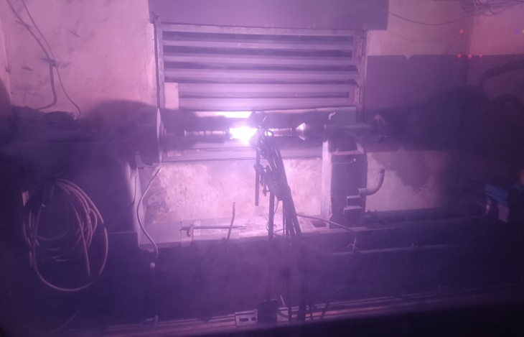

Dimension should be checked in between number of passes to control dimension as per Data Evaluation Card.

After getting the desired thickness of the coating, stop the spraying process.

Cool the job gradually to room temperature and recheck the dimension of the component.

Fill up the Job Card with relevant data of spray parameters.

Tag the job card with the sprayed component.

Shutdown :

Shut the Powder Feeder and wait for the feed lines to clear.

Select the Stop switch to shut down the ignition.

Press purge switch to cool the gun hardware.

Stop the Exhaust fan, Chiller and water pump.

Stop the main switch to shut the Control Unit.

Assessor : |  | Signature: |  | Date:
Approved: |  | Signature: |  | Date:

